**Bayesian Network**

1. **To build the Bayesian Network, we need to specify the graph structure and the conditional probabilities as the following:**

**bayn = BM([('diff','grad'),('intel','grad'),('intel','sat'),('grad','lett')])**

**cpd_diff = TC(variable='diff', variable_card=2, values=[[0.6], [0.4]])**

**cpd_intel = TC(variable='intel', variable_card=2, values=[[0.7], [0.3]])**

**cpd_sat = TC(variable='sat', variable_card=2, values=[[0.95,0.2], [0.05,0.8]], evidence=['intel'],evidence_card=[2]) cpd_grad = TC(variable='grad', variable_card=3, values=[[0.3,0.05,0.9,0.5], [0.4,0.25,0.08,0.3],[0.3,0.7,0.02,0.2]], evidence=['intel','diff'],evidence_card=[2,2])**

**cpd_lett = TC(variable='lett', variable_card=2, values=[[0.1,0.4,0.99], [0.9,0.6,0.01]],evidence=['grad'], evidence_card=[3])**

**bayn.add_cpds(cpd_diff, cpd_intel, cpd_sat, cpd_grad, cpd_lett)**

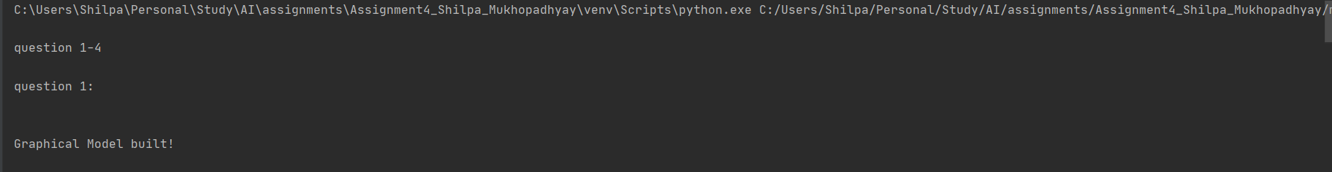

1. **You can view the summary of the network, i.e. the nodes and the edges and check the validation of conditional probabilities using the following methods:**

**print(bayn.nodes())**

**print(bayn.edges())**

**print(bayn.check_model())**

**What information do the edges of the graph induce? (5 points)**

Ans: The edges of the graph represent the parent-child relationship of the Bayesian Network.



1. **The marginal distribution for all the 5 variables can be found by VariableElimination. bayn_infer = VE(bayn)**

**q_diff = bayn_infer.query(variables=['diff'])**

**q_intel = bayn_infer.query(variables=['intel'])**

**q_sat = bayn_infer.query(variables=['sat'])**

**q_grad = bayn_infer.query(variables=['grad'])**

**q_lett = bayn_infer.query(variables=[‘lett'])**

**Explain how does the variable elimination works. (5 points)**

We define the variable elimination (VE) algorithm. Essentially, we loop over the variables as ordered by O and eliminate them in that ordering. Intuitively, this corresponds to choosing a sum and “pushing it in” as far as possible inside the product of the factors

More formally, for each variable Xi (ordered according to O),

1. Multiply all factors Φi containing Xi
2. Marginalize out Xi to obtain a new factor τ
3. Replace the factors Φi with τ

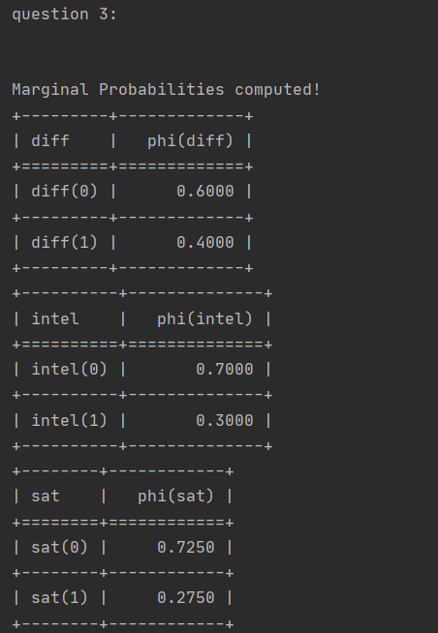

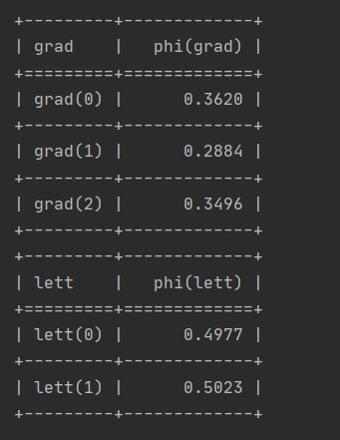

1. **Finally, all the conditional independencies satisfied by the Bayesian network can be listed.**

**print(bayn.get_independencies())**

**Write down the Markov blanket corresponding to each variable. (10 points)**

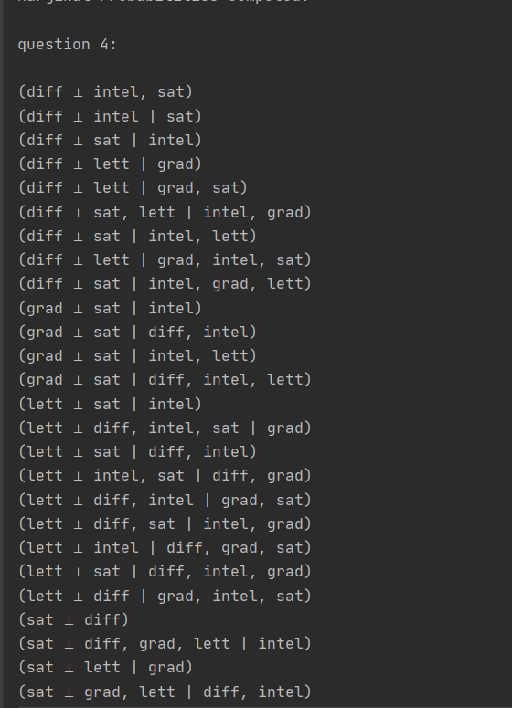

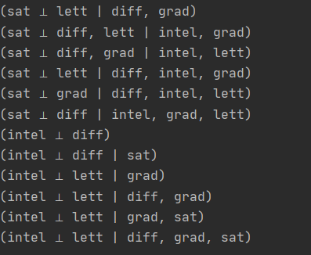

Markov Blanket:

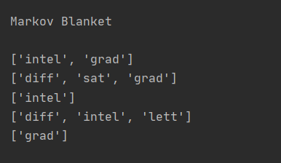

1. **Build the corresponding graphical models as shown in step 1. (5 points)**

print('\nquestion 5:\n')  
bayn = BM([('smokes', 'lung_disease'), ('lung_disease', 'shortness_of_breath'), ('lung_disease', 'chest_pain'), ('lung_disease', 'cough'), ('cold', 'cough'), ('cold', 'fever')])  
cpd_smokes = TC(variable='smokes', variable_card=2, values=[[0.2], [0.8]])  
cpd_cold = TC(variable='cold', variable_card=2, values=[[0.02], [0.98]])  
cpd_lung_disease = TC(variable='lung_disease', variable_card=2, values=[[0.1009, 0.001], [0.8991, 0.999]],  
 evidence=['smokes'], evidence_card=[2])  
cpd_shortness_of_breath = TC(variable='shortness_of_breath', variable_card=2, values=[[0.208, 0.01],  
 [0.792, 0.99]],  
 evidence=['lung_disease'], evidence_card=[2])  
cpd_chest_pain = TC(variable='chest_pain', variable_card=2, values=[[0.208, 0.01],[0.792, 0.99]],  
 evidence=['lung_disease'], evidence_card=[2])  
cpd_cough = TC(variable='cough', variable_card=2, values=[[0.7525, 0.505, 0.505, 0.01], [0.2475, 0.495, 0.495, 0.99]],  
 evidence=['lung_disease', 'cold'], evidence_card=[2, 2])  
cpd_fever = TC(variable='fever', variable_card=2, values=[[0.307, 0.01], [0.693, 0.99]],  
 evidence=['cold'], evidence_card=[2])  
bayn.add_cpds(cpd_smokes, cpd_cold, cpd_lung_disease, cpd_shortness_of_breath, cpd_chest_pain, cpd_cough, cpd_fever)  
print('\nGraphical Model built!')



1. **Print the network summary and verify the conditional probabilities as in step 2. (5 points)**



1. **Compute the marginal probabilities for each variable as in step 3. (5 points)**

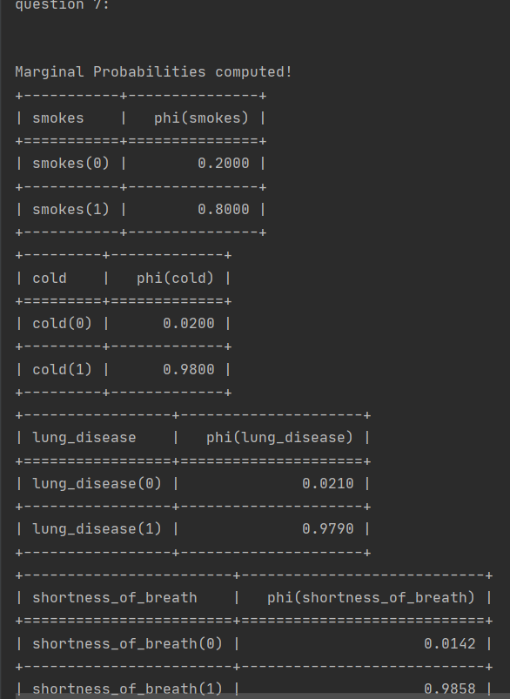

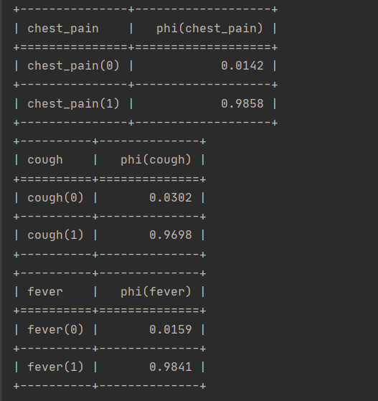

1. **List all the conditional independencies as in step 4. (5 points)**

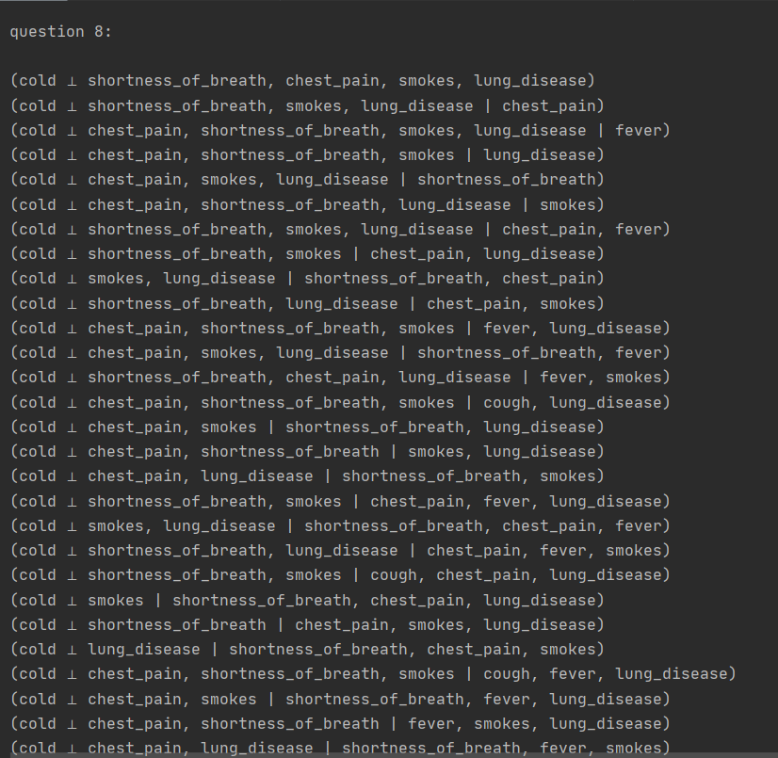

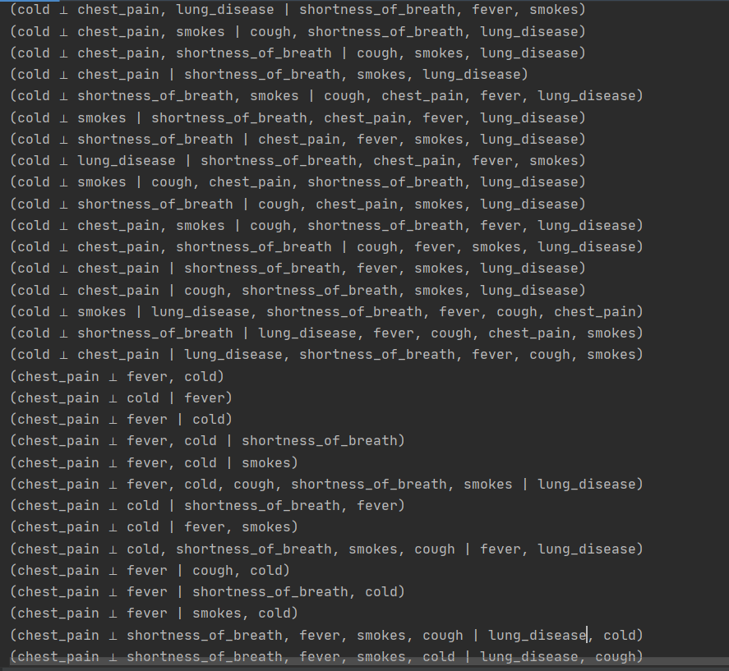

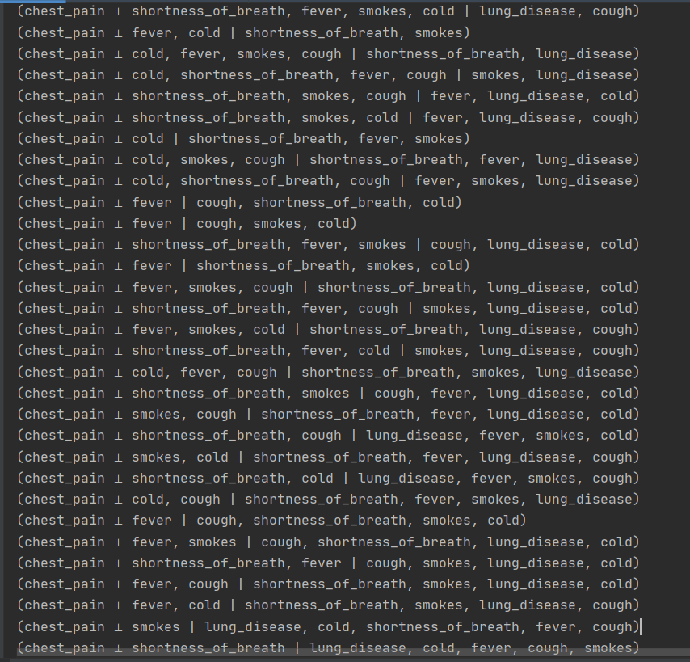

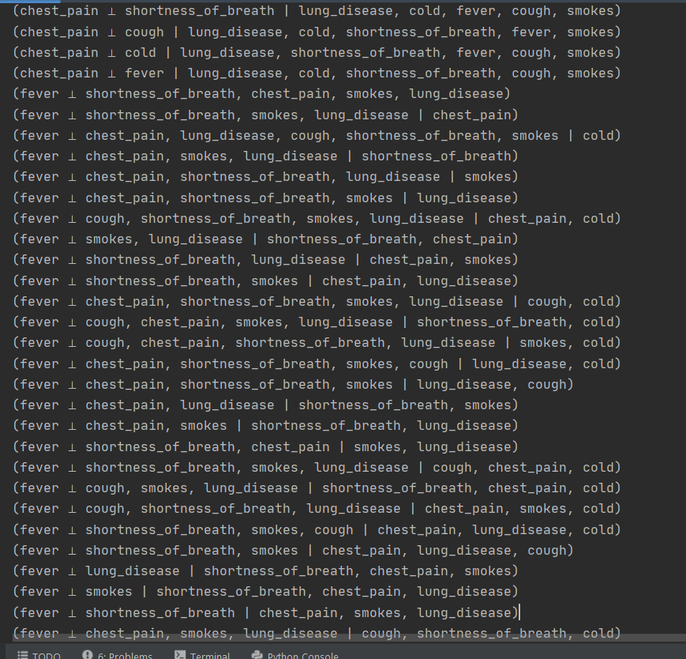

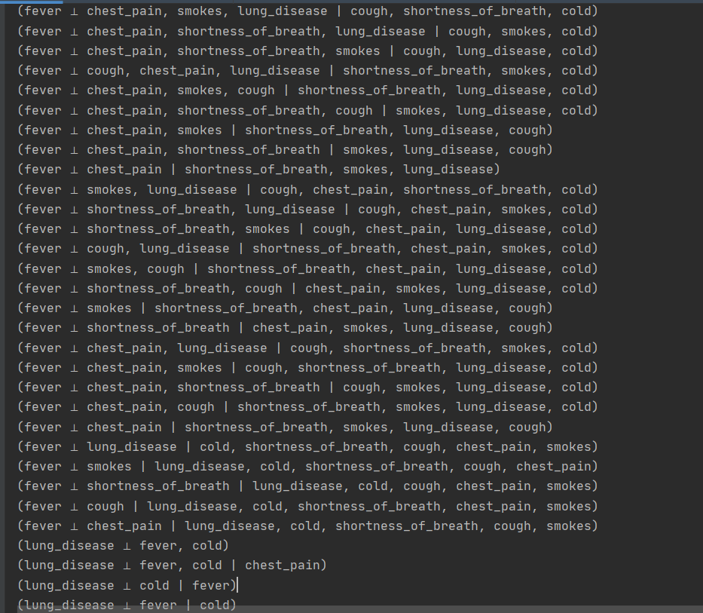

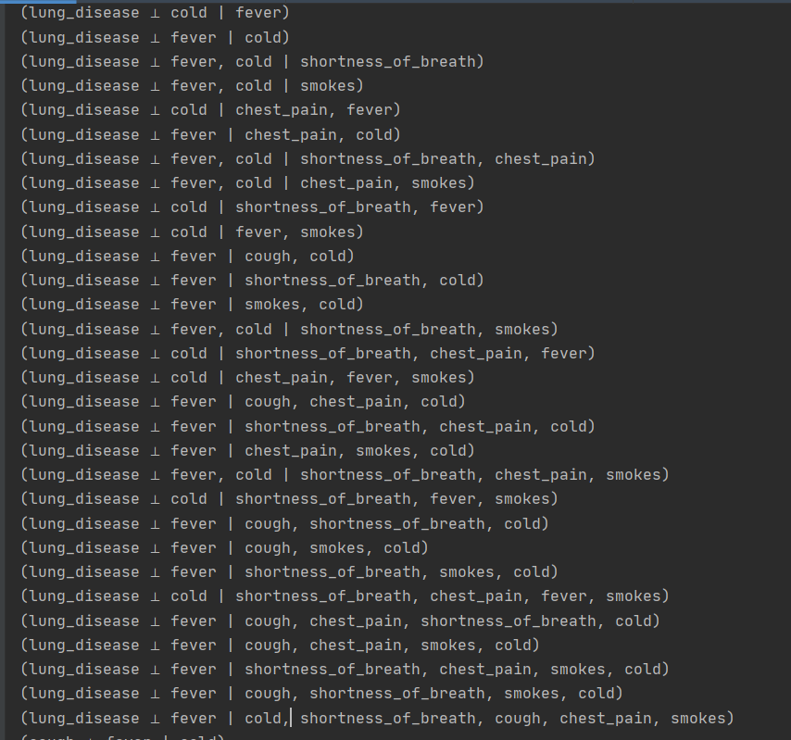

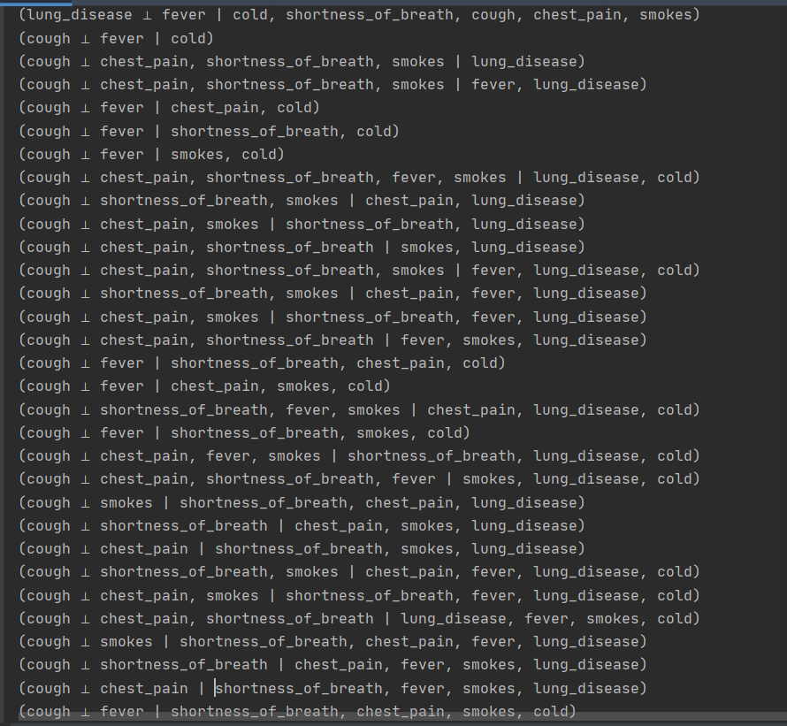

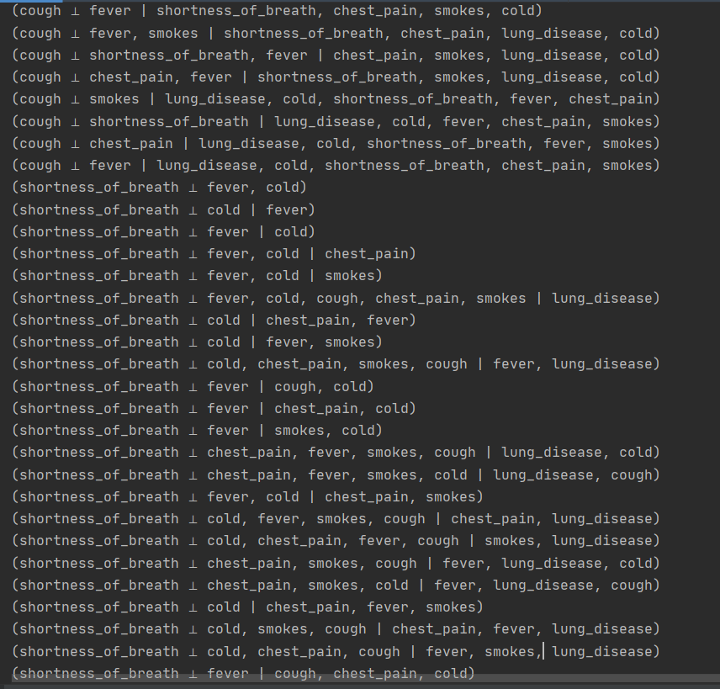

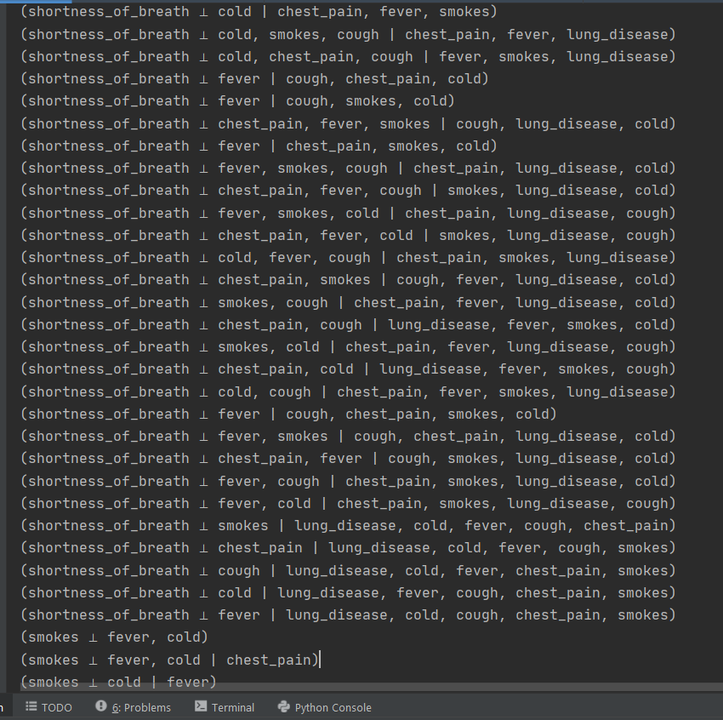

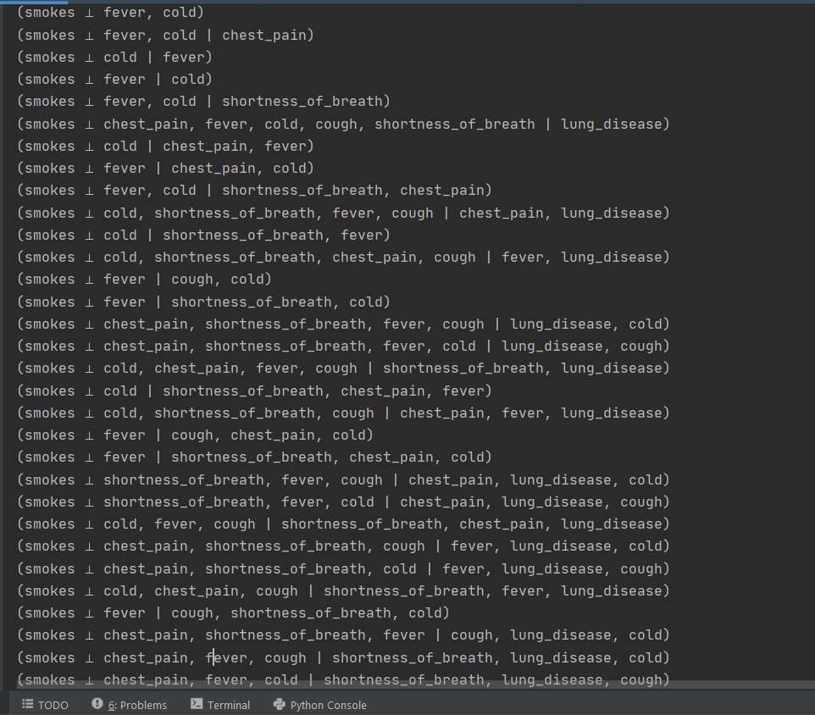

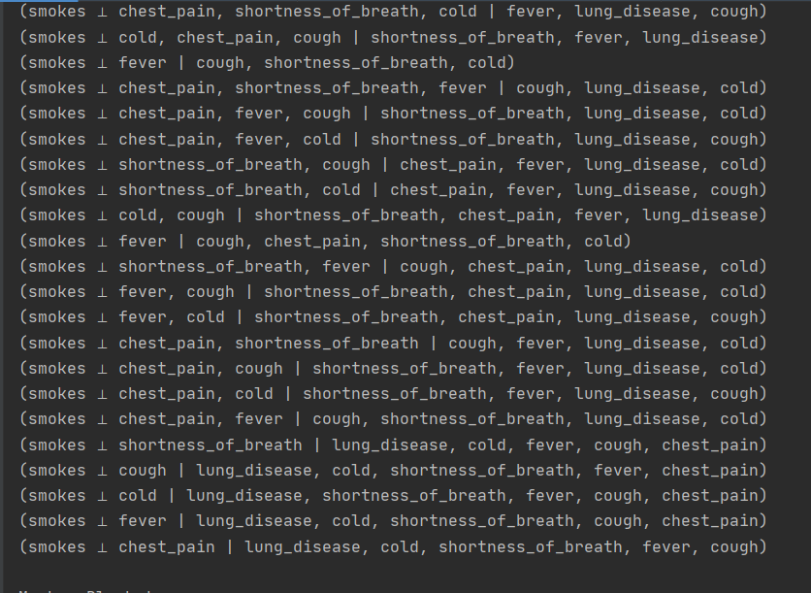

Markov Blanket:

